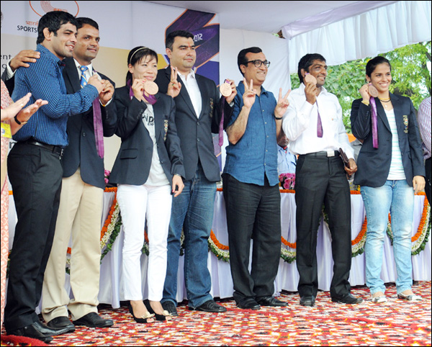
August 17, 2012, New Delhi : Sports Minister Shri Ajay Makan announced the launch of “OPEX Olympics -2020” targetting to get 25 Medals. Cash awards of Rs 30 lakh each were presented to the Silver Medallists --Sushil Kumar and Vijay Kumar, and Rs 20 lakh each to the four Bronze Medal winners including Saina Nehwal.
The players were later taken to Amar Jawan Jyoti at India Gate in open jeeps and they paid floral tributes to the martyrs.

